**Claim:**

Biofuels are more efficient and have less environmental impact than fossil fuels.

**Rationale**

The concept of fuel to facilitate a combustion reaction has been around for millennia. From the use of wood to create a campfire to modern combustion engines powering today’s transportation, all are governed by the same principles. These can be simplified into the visual aid of the fire triangle. The fire triangle states that for fire to occur you must have heat, oxygen and fuel, without one of these the reaction will either not begin or will cease. The chemical reaction formula for combustion is as follows (reference).

$$Hydrocarbon+O_{2}→CO_{2}+H_{2}O$$

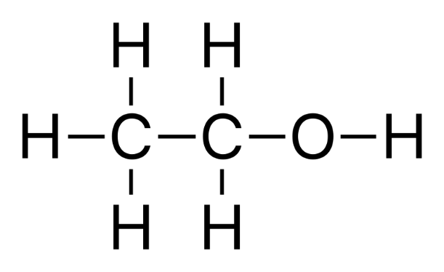Modern chemical fuels primarily comprise of hydrocarbons. This is because they contain very high amounts of chemical potential energy released in a combustion reaction. This group includes fossil fuels such as coal, oil and natural gas but also other fuels such as biofuels. Hydrocarbons are chemicals comprised of carbon with various hydrogen atoms or other compounds attached (reference). Petroleum, the fuel used in the majority of vehicles is made up of several different types of hydrocarbons and not a single type. This is unlike bioethanol, which is entirely made up of ethanol. Ethanol in everyday life is the chemical in alcoholic drinks which causes drunkenness. The chemical formula for ethanol combustion and structure of ethanol is as follows.

$$C_{2}H_{5}OHO_{2}+{3O}_{2}→2CO_{2}+{3H}_{2}O$$

Its name also can be used to derive the chemical formula, ‘eth’, meaning it has two carbon atoms and ‘ol’ meaning it has and $OH$ functional group. Extra Hydrogen atoms are then added to saturate the carbons bonds of the compound. In the combustion reaction it can be seen that the even though ethanol has a different chemical structure than the standard hydrocarbon ethane, the reaction shares the same products of carbon dioxide and water. Ethanol is primarily manufactured by fermenting starches in grains or sugars other plants. This is the same process used to create the ethanol found in alcoholic drinks. When producing ethanol in mass for the purpose of fuel a plant which has the most reactant compared to the environmental and economical to produce the plant should be chosen. One of these potential plants to be used in ethanol production is cassavas. As global reserves of fossil fuels dwindle and prices of petroleum rises, demand for cassavas for use in energy productions has increased (second report). This is due to many factors including being able to grow in various climates, requiring little farmer intervention, having the ability to grow in any season and the rapid growth of the plant. This evidence has led to the following research question:

*Is cassava-based ethanol production a viable and safe alternative energy source to petroleum?*

**Discussion of Evidence**

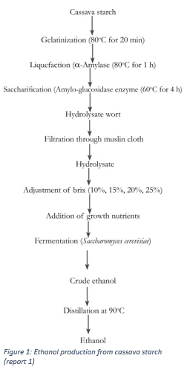When comparing the effectiveness of a fuel there are four major criteria. These are economic cost, available use cases, energy output and environmental impact. Since petroleum is still the dominant fuel around the world it overall is currently the most effective fuel (wwf). However, with the foreseeable scarcity of fossil fuels it is reasonable to assume that the economic cost will continue to increase. Therefore, even if there is no advancement in renewable technology there will become a time where it will become most effective out of necessity. Knowing this case, the search for the most effective renewable fuel becomes very important for society.

Figure 1 shows the process of converting cassava starch into pure ethanol. It shows that relative simplicity of the process and that it can be automated in on a large scale. The steps also do not have particularly harmful effects on the surrounding environment. This is unlike petroleum which requires drilling. This drilling disrupts ecosystems, requires the clearing of vegetation and has other environmental consequences. Like all hydrocarbons ethanol produces carbon dioxide, a harmful greenhouse gas. However, looking at the bigger process shows that carbon dioxide released by bioethanol is the same gas absorbed in the farming process making it more sustainable when compared to crude oil being pumped out of the ground.

According to the U.S. energy information administration the energy contents of pure ethanol is 33% lower than petroleum. This is not ideal, however to mitigate this issue ethanol is commonly used as a fuel additive to car fuel. This is a good short-term solution as it creates a demand for ethanol using existing engine technology.

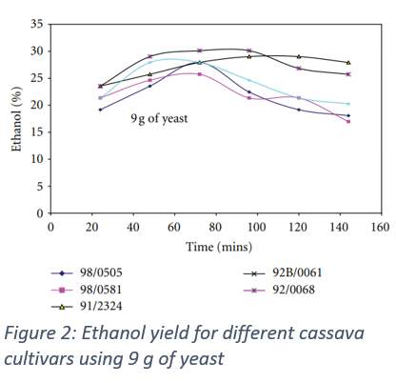Figure 2 shows the results from an experiment converting cassava flower into ethanol using yeast as a catalyst. The different coloured lines represent different suppliers of cassava it shows after over the three-hour period ethanol concentration produced varied up to 50%. It also shows the potential of the cassava plant as a source of ethanol.

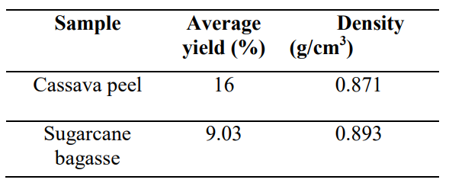Figure 3 shows the results from a different experiment comparing the yield of ethanol by fermenting cassava peels and sugarcane. It finds that the density of the ethanol is very similar however the percentage yield of the cassava peels is higher. This means that of the two primary plants used in the production of bioethanol

References

<https://www.sciencedirect.com/science/article/pii/S0189724115300448>

<https://downloads.hindawi.com/archive/2013/916481.pdf>

https://www.journals.chemsociety.org.ng/index.php/jcsn/article/download/263/317

<https://www.eia.gov/energyexplained/biofuels/ethanol.php>

<https://wwf.panda.org/discover/knowledge_hub/teacher_resources/webfieldtrips/climate_change/petroleum>

<https://www.eia.gov/tools/faqs/faq.php>